**Experiment No:12**

**Aim: Perform Remote login using Telnet server**

# Theory:

The telnet command is used for interactive communication with another host using the TELNET protocol. It begins in command mode, where it prints a telnet prompt ("telnet> "). If telnet is invoked with a host argument, it performs an open command implicitly; see the description below.

Options:

-4 Force IPv4 addressresolution.

-6 Force IPv6 addressresolution.

-8 Request 8-bit operation. This causes an attempt to negotiate theTELNETBINARY

option for both input and output. By default telnet is not 8-bit clean.

-E Disables the escape character functionality; that is, sets the escape characterto

``no character''.

-K Specifies no automatic login to the remote system.

-L Specifies an 8-bit data path on output.This causes the TELNET BINARY option to negotiated on just output.

Once a connection has been opened,**telnet**will attempt to enable the TELNETLINEMODE option.If this fails, then**telnet**will revert to one of two input modes:either “character at a time” or “old line by line” depending on what the remote systemsupports

## Steps to Install and Use Telnet in Ubuntu:

**Step 1:** Firstly, open the**“Terminal”**window by pressing**“Ctrl + Alt + T”**. In the figure, you may see**“$”**that signifies that you are not logged in as a root user.

So, I”ll write**“sudo apt-get install telnetd”**and press enter. If you are a root user, then you don’t need to write sudo in Ubuntu.**“telnetd”**is a daemon that gets invoked 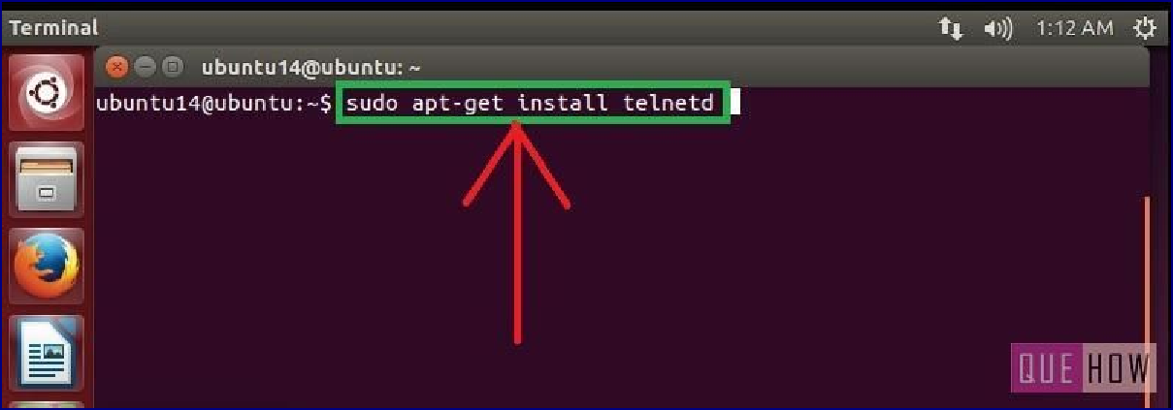by*“inetd”or its extension “xinetd”*, both are the internet servers.

**Step 2:**Then you are asked to enter the user password and then press enter. Processing will start as soon as you press enter. After this, I have noticed a line**“274 KB additional disk space will be used”**on the terminal screen.

You may also observe some sort of a message like this and then you”ll be asked to continue or not. Just write**“y”**and then press enter to continue.

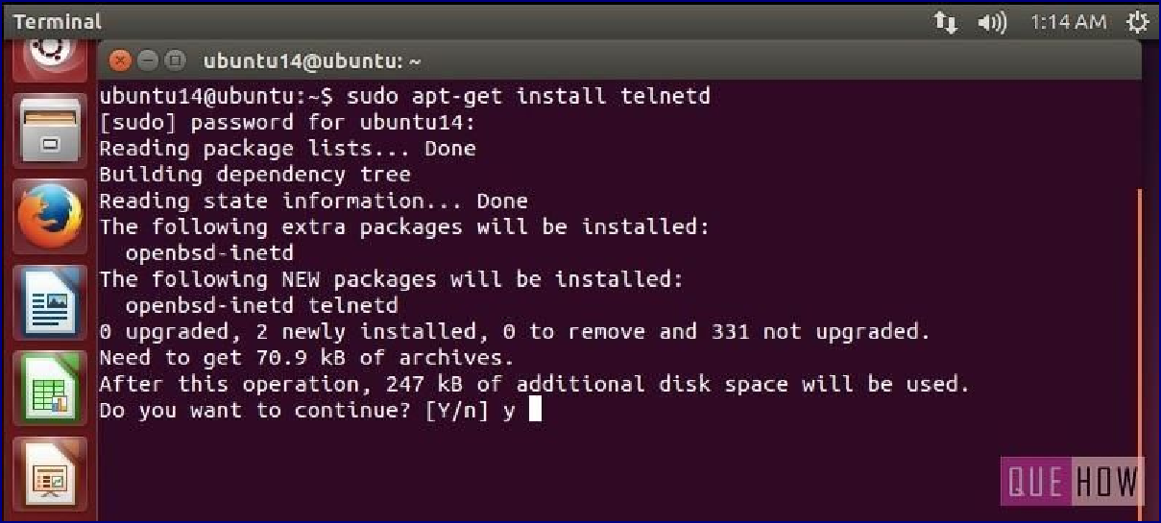

**Step 3:**Now when you are done with it,**restart “inetd”**. Type**“sudo**

## /etc/init.d.open-bsd-inetd restart”.

*“inetd”*is daemon used for*dealing with incoming network*and it is responsible for deciding which program to run when a request comes.

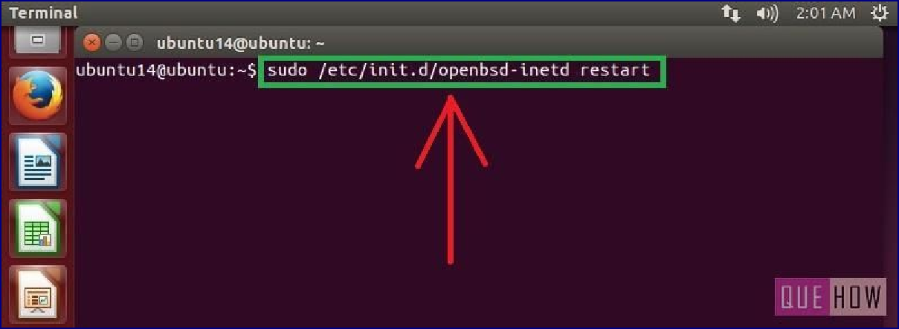

**Step 4:**To ensure “inetd” is started, press enter after writing the above command.

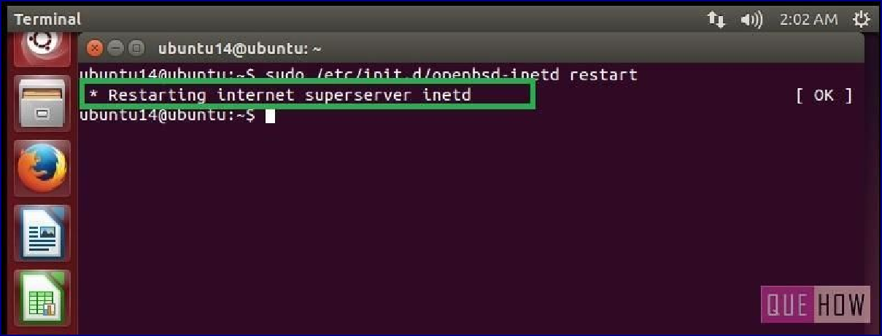

## To connect with any remote client:

**Step 5:**Just type:**“telnet hostipaddress”**. For an example: “telnet 122.175.140.221” and press enter.

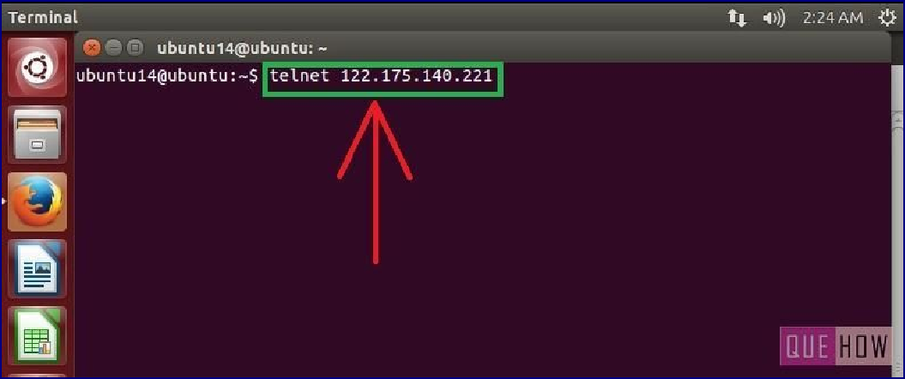

**Step 6:**Then you”ll see, it is connected to**“host ip address”**. For security reasons, you 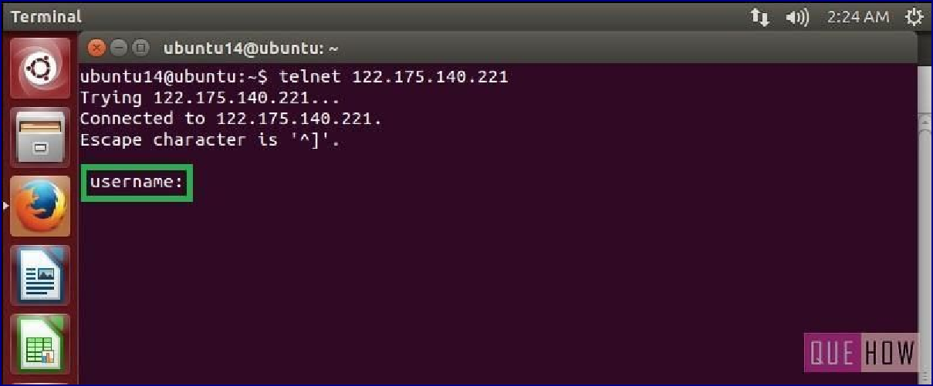are required to provide “username” and “password” as well.

**Output-**

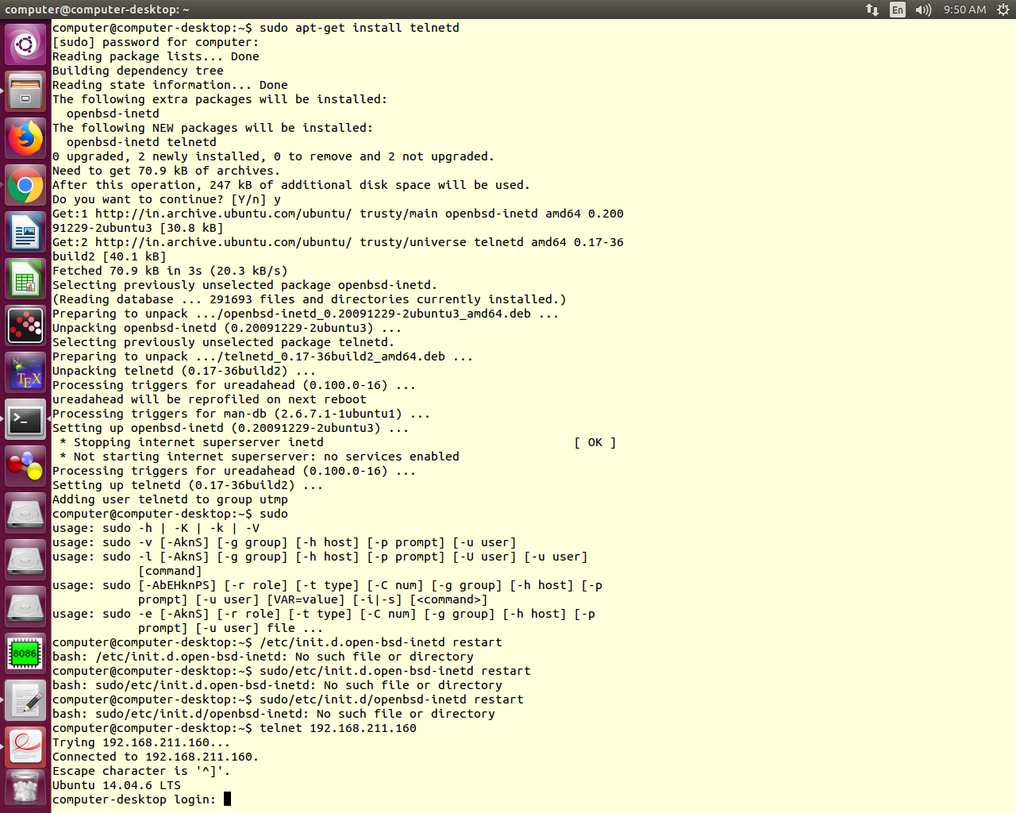

**Conclusion:** Hence we successfully installed and used telnet..